**Inventory and Asset**

**Management system**

Project Proposal

By

**Mr. Nathawut Supavananusorn 542115020**

**Mr. Tanadol Parn-ong 542115021**

Department of Software Engineering

College of Arts, Media and Technology

Chiang Mai University

Project Advisor

________________________

**Dr. Prompong Sugunnasil**

**Document History**

|  |  |  |  |  |  |  |
| --- | --- | --- | --- | --- | --- | --- |
| **Document Name** | **Version** | **Status** | **Date** | **Viewable** | **Reviewer** | **Responsible** |
| **Documents** | | | | | | |
| Inventory and Asset Mangement_v0.1.docx | Create Chapter One  -Abstract  -Introduction and Background | Draft | 1 Jan 2015 | NS, TP, PS | NS,TP | TP |
| Inventory and Asset Mangement_v0.2.docx | Create Chapter Two  -Business Review | Draft | 9 Jan 2015 | NS, TP, PS | NS,TP | TP |
| Inventory and Asset Mangement_v0.3.docx | Create  - Technology Review  - Development Tool Review | Draft | 11 Jan 2015 | NS, TP, PS | NS,TP | TP |
| Inventory and Asset Mangement_v0.4.docx | Create  - Chapter Three Quality Standard  - Chapter four Project Plan  1. Motivation  2.Aim and objectives  3.Deliverables and limits  4 Future Work  5.Software Process  6.Schedule & Milestones | Draft | 11 Jan 2015 | NS, TP, PS | NS,TP | TP |
| Inventory and Asset Mangement_v0.5.docx | Fix  -fix page Layout Feature content | Draft | 12 Jan 2015 | NS, TP, PS | NS,TP | TP |
| Inventory and Asset Mangement_v0.6.docx | Fix  -fix abstract  -fix introduction  -fix feature | Draft | 13 Jan May 2015 | NS, TP, PS | NS,TP | TP |
| Inventory and Asset Mangement_v0.7.docx | Fix  -fix abstract content | Draft | 3 June 2015 | NS, TP, PS | NS,TP | TP |

**\*NS = Nathawut Supavananusorn**

**\*TP = Tanadol Parn-ong**

**\*PS = Dr. Prompong Sugunnasil**

**Abstract**

College of Arts, Media and Technology, there are IT staffs to record about durable articles, to plan the purchasing, and to repair durable articles. The report of the broken durable article is done by the user. The user will fill in the report form and submit to the IT department. There are several weaknesses in this process, such as the loss of the document. As a consequence, the broken article might not get fixed.

The objective of this project is to build a web application for durable articles management. This system is called “Inventory and Asset Management system”. The durable articles management system has the ability to manipulate the information about the article, and the management information system analyzes information about durable articles. This system can help the staff to manage and plan for purchasing new media easily. Moreover, this system also provides the tracking system, which helps reporters for tracking reparation process of durable articles by notification via emails. Repairing system helps technicians to manage reparation information.

This system consists three users. The first user is Administrator, he can manage the durable articles (add, update, and delete durable articles information) and access to Management Information system to search the summary report about repairing media. The second user is the technician, he can check the details of inform about broken durable articles come in and update the reparation information. Third user is the reporter, he can inform detail about broken durable articles into the system, which the technician knows those detail and repair it.

Contents

**Chapter One | Introduction and Background** 6

**Chapter Two | Literature Review** 7

**2.1**  **Business Review** 7

2.1.1 iSoftService [1] 7

2.1.2 Service Center [2] 9

2.2 Technology Review 11

2.2.1 ASP.NET MVC [3] 11

2.2.2 Cascading Style Sheets 3 (CSS3) [4] 12

2.2.3 HTML [5] 13

2.2.4 JavaScript [6] 14

2.2.5 Cloud server [7] 15

2.3 Development Tool Review 16

2.3.1 Microsoft SQL Server [8] 16

2.3.2 Microsoft Visual Studio [9] 17

2.3.3 Adobe Photoshop [10] 18

2.3.4 Mandrill [11] 19

2.3.5 Window Azure [12] 20

2.3.6 Internet Information Service (IIS) [13] 21

2.3.7 Bootstrap [14] 22

Chapter Three | Quality Standard 23

3.1 ISO 29110 for Very Small Entity (VSE) 23

3.1.1 Project management process 23

3.1.2 Software implementation process 23

Chapter Four | Project Plan 24

4.1 Motivation 24

4.2 Aim and objectives 24

4.2.1 Aim 24

4.2.2 Objectives 24

4.3 Deliverables and limits 25

4.3.1 System Architecture 25

4.3.2 Deliverables 26

4.3.3 Limits 26

4.4 Future Work 26

4.5 Software Process 27

4.6 Schedule & Milestones 28

4.6.1 Features 28

**Chapter Five | References** 35

# **Chapter One | Introduction and Background**

Nowadays, the management of media of College of Arts, Media and Technology, there is the IT staff to manage the durable articles (projectors, computers, and another tool). For the each year, College of Arts, Media and Technology records the durable articles list and plans to purchase the new durable articles for instead of the old one. Microsoft Excel program is used for recording the detail of College of Arts, Media and Technology's media. There are IT staffs to take care or to repair the durable articles. The repairing informs of durable articles, which use durable articles or the owner of durable articles have to fill broken durable articles information in the form paper and request to staff.

From above, the IT staff of College of Arts, Media and Technology spends a lot of time to record the details or plan to purchase a new durable articles for instead of the old, almost expire or losing. It is very difficult to analyze the brand of durable articles, it often loses which it is a part of planning to purchase the new media. Moreover, to inform to repair, it is many processes and take a lot of times. There is a problem for the IT staff to provide the job of durable articles not be equal. It makes to late for repairing durable articles.

“Inventory and Asset Management system” can be solved the problems which there is the system to manage the durable articles (add, update, delete durable articles information). Information Management system is used for reporting the brand of durable articles, it usually loses or reports the durable articles almost expire, statistics of inform to repairing durable articles for each month. This system can be helped the IT staff to manage and plan about the durable articles easily. Besides, there is a system by using the web application to provide the job of durable articles, and it makes the staff equal to the job for each one. There is the system to update the predicament of durable articles by Email.

# **Chapter Two | Literature Review**

## **2.1 Business Review**

The general repairing management system is a tool for helping technicians about repairing media. It contributes to managing or allocate jobs of each technician. Moreover, it can record broken media detail, which technicians are unnecessary to remember those detail, but they use repairing management system for recording detail.

### 2.1.1 iSoftService [1]

iSoftService is an application about repair management system. The repair center can use this system to manage the product repairing, and notify to technicians about their work. This system provides the user to get a servicing report. iSoftService supports major features as follows,

1. This system provides technicians to manage their repairing works.
2. This system provides technicians to record repairing works.
3. This system provides technicians to find their works.
4. This system provides technicians to check the progress of repairing works.

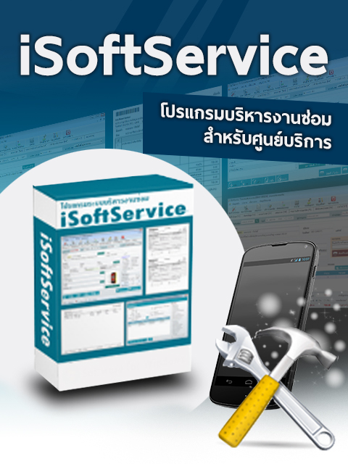

*Figure 1 iSoftService’s logo*

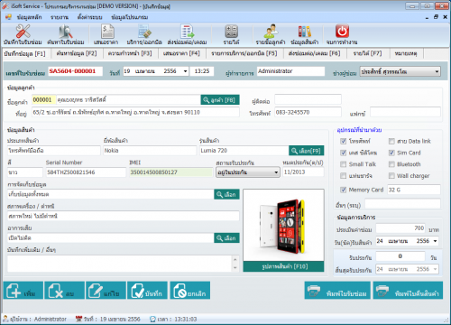

*Figure 2 iSoftService main page Demo Version*

Figure 1 shows iSoftService's logo for sale. There is software interface on iSoftService full box package.

Figure 2 shows the interface of item information page (Demo version) where users can input item information that is repaired. On the right side of Figure 2 provides the user to select an item that is repaired and to display after sales service time.

Pros

iSoftService provide several functions about repairing system for technicians such as recording repairing information, finding servicing information, calculating income, and other functions. This system provides servicing collaboration between departments in the service center.

Cons

iSoftService is not freeware. The users must spend a lot of money for purchasing the license. iSoftService does not have the tracking system and the system for help to distribute works of each technician equally. iSoftService user interface has function complexity, so this system is hard to use for beginning user.

### 2.1.2 Service Center [2]

Service Center is developed for repairing management. This system uses for repair and installation, such as appliance repair service center, PC repair shop, and mobile repair shop. This system is convenient for the general repair shop. Service Center supports major features as follows,

1. This system provides the user to record service and repair work.
2. This system provides the user with search product, the status of repair works.
3. This system provides interaction between system and user with friendly interactive.
4. This system provides the user to check information and the progress of repair works.

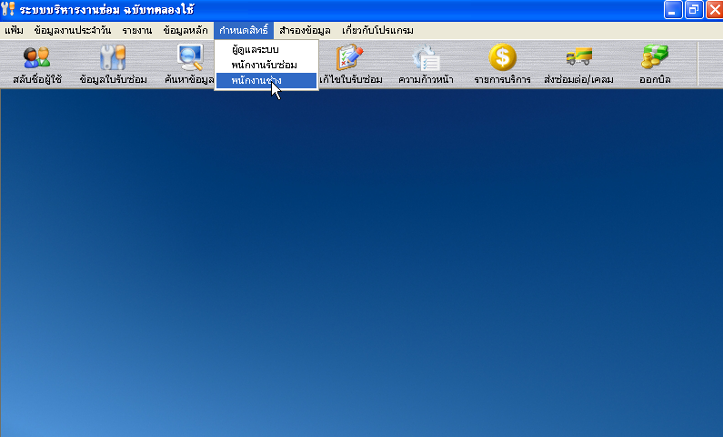

*Figure 3 Service Center main page*

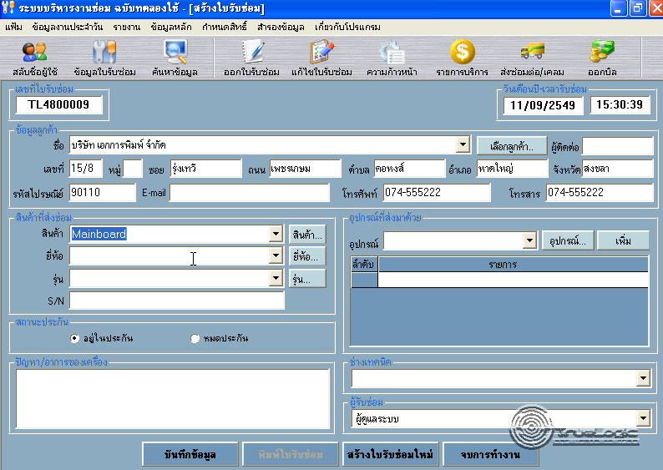

*Figure 4 Service Center repairing information page*

Figure 3 shows the interface of the main page. On the top side of Figure 3 provides the user to use the options menu for repair management.

Figure 4 shows the interface of the repairing page where users can manage repair information. On the left side of Figure 4 provides the user to input the item information.

Pros

Service Center is an application that provides convenient to repairing technicians. This system provides basic functions to manage repair information such as the user account and user permission, searching information, and other essential functions, which are appropriate general repair shops.

Cons

This system does not have the tracking system, which affect to the technicians must spend too much time on repair management and distribute works of each technician, because his system cannot work with the internet. This system is hard to use for the user who does not have experience about repair management because there functions a diverse and scattered in a single system.

## Technology Review

### ASP.NET MVC [3]



*Figure 5 ASP.NET MVC*

Technology Description

MVC is a framework for building web application using MVC design pattern. The concept of MVC design pattern will manage (separate) task and element in application to easy for building and development.

Alternative technology

- PHP, JSP

The selection of this technology

. - ASP.NET MVC can build dynamic web application.

- ASP.NET MVC is easy to adapt object oriented programming concept.

### Cascading Style Sheets 3 (CSS3) [4]



*Figure 6 Cascading Style Sheets 3 (CSS3)*

Technology Description

CSS3 is a Style Sheets language to help to define the look and formatting of a document written in a markup language. It is commonly used to create interfaces written in HTML and XHML.

Alternative technology

- CSS2

The selection of this technology

**-** CSS3 is easier to implement page layout

- CSS3 is considered a clean coding technique.

- CSS3 can work with HTML5 and provide a richer set of features (e.g. text effects, 2D/3D transformations, animations).

### HTML5 [5]



*Figure 7 HTML*

Technology Description

Hypertext Markup Language (HTML) is a standard language for using design web pages. HTML use Tag for define HTML displaying. HTML language is a Markup language that use for building web pages. HTML has a template from SGML (Standard Generalized Markup Language) for to understand and easy to learn. Currently being developed and standardized by the World Wide Web Consortium (W3C).

Alternative technology

- HTML4

The selection of this technology

- HTML5 can access sites easier than older version.

- HTML5 is support multimedia content.

- HTML5 is standardized for creating the user interface of website.

### JavaScript [6]



*Figure 8 JavaScript*

Technology Description

JavaScript is a programming language known as the “script”. Translation operates on each command. It is commonly used as part of web browsers, which allow client-side scripts to interact with the user, control the browser, and change the content displayed on the We can add the JavaScript programming web pages to process data of both the display and receiving - transmitting. And that can interact with users immediately. JavaScript is also used in server-side programming and building games as well as desktop and mobile applications.

Alternative technology

- Haxe

The selection of this technology

- We use JavaScript for calculating data, displaying, sending – receiving data for interacting with the user.

- JavaScript is easy to learn.

### Cloud server [7]

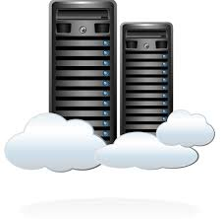

*Figure 9 Cloud server*

Technology Description

Cloud servers mean virtual servers that run on cloud computing. A cloud server is a logical server that is built, delivered, and hosted from a cloud computing. Cloud servers accessed remotely from a cloud service provider. Cloud servers run as software-independent units. Cloud server has all the software it requires to run and does not depend on any centrally-installed software. Cloud server probably hold the best stability performance.

Alternative technology

- Dedicated Server Hosting

The selection of this technology

- Increase resources: Cloud server providers can provide more resource when resources are insufficient as the demand increases.

- Maintenance: Cloud server supports easy maintenance. The administrator can access to the server from different places.

- Security: Cloud server providers devote resources to security. Users can rely on their service providers for secure data storage and transfer.

## Development Tool Review

### Microsoft SQL Server [8]

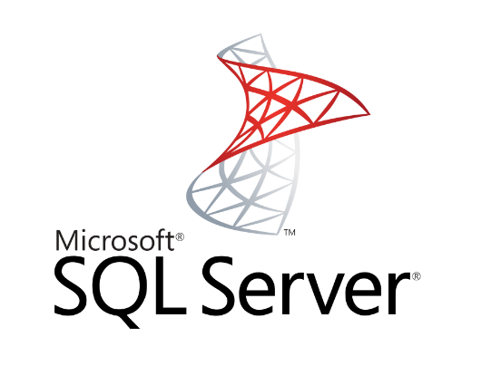

*Figure 10 MS SQL Server*

Tool description

Microsoft SQL Server is a [relational database management system](http://en.wikipedia.org/wiki/Relational_database_management_system) developed by [Microsoft](http://en.wikipedia.org/wiki/Microsoft). As a database, it is a software product whose primary function is to store and retrieve data as requested by other software applications.

Alternative technology

- SQLite

- MySQL

- Microsoft Access

The selection of this tool

- Microsoft SQL Server can use T-SQL language for querying data.

- Microsoft Visual studio can be easily used with Microsoft SQL Server.

### Microsoft Visual Studio [9]

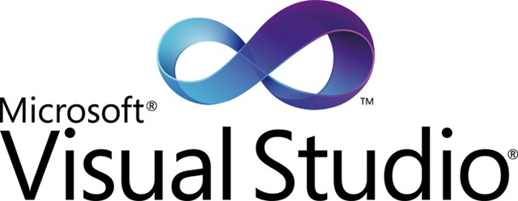

*Figure 11 MS Visual Studio*

Tool description

Microsoft Visual Studio is Integrated Development Environment developed by Microsoft. It enables developers to develop a wide variety of software including web applications and web services that are compatible with Microsoft Windows technologies and devices. Visual Studio supports. Net languages which include VB.NET, C++, C#.

Alternative tool

- Sublime

- Xamarin

The selection of this tool

* Microsoft Visual studio is used for developing ASP.NET MVCFramework.

### Adobe Photoshop [10]



*Figure 12 Photoshop*

Tool description

Adobe Photoshop is a program that helps create and edit images. It is also equipped with many tools to support the creation of video and multimedia presentations as well as to design and develop websites. Adobe Photoshop software package consists of two programs, Photoshop and ImageReady.

Alternative tool

- GIMP (cross-platform).

- Paint.NET (Windows only).

The selection of this tool

- Photoshop can create and edit images for user interface.

### C:\Users\nathawut\AppData\Local\Microsoft\Windows\INetCache\Content.Word\logo-vertical-light-735b5657.png Mandrill [11]

*Figure 13 Mandrill*

Tool description

Mandrill provides the user to flexible. Mandrill provides the user to send mail from more than one domain within a single Mandrill account, with no additional fees. Mandrill can make the transition to a new dedicated IP easier by automatically ramping up sending over a 30-day period. Mandrill is a scalable and affordable email infrastructure service. Mandrill has servers around the world which makes to send mail faster.

Alternative tool

- Google Gmail API

The selection of this tool

- Mandrill authenticates your mail automatically.

- Mandrill's IPs are automatically registered for feedback loops with ISPs.

- Mandrill can make the transition to a new dedicated IP easier

- Mandrill provide user send from more than one domain within a single Mandrill account.

### Window Azure [12]

Tool description

Window Azure is a cloud computing platform, which has been developed by Microsoft. Window Azure is used to build, deploy and manage applications and services via a global network of Microsoft-managed datacenters. Window Azure provides Platform as a Service and Infrastructure as a Service also, it supports different programming languages. Platform as a Service use for providing customers rent tools, libraries, storage, operating system and network capacity from the provider. Infrastructure as a Service use for providing customers rent the virtual machine, storage, hardware and server from the provider.

Alternative tool

Amazon cloud drive, Iris cloud computing

The selection of this tool

* We use Cloud service of Window Azure because it is Platform as a Service. Cloud service is containers of hosted applications. These applications can be the web application or private processing engines for works.
* Cloud computing renter can pay an amount of money that depend quantity of resources.
* Window Azure deploy software that was develop by using .Net framework is easily.
* Rate of downtime is less because Microsoft guaranteed rate of uptime is 99.9%.

### 2.3.6 Internet Information Service (IIS) [13]

Tool description

Internet Information Service (IIS) is a web server developed by Microsoft. It is a secure, easy-to-manage, modular and extensible platform for reliably hosting websites, services and applications and provides a set of Internet-based services for servers including HTTP, HTTPS, FTP, FTPS, and SMTP.

Alternative tool

- None

The selection of this tool

* Internet Information Service works with .Net, both of which are developed by Microsoft.
* Internet Information Service is a part of the Window operating system. It is easy to using.

### 2.3.7 Bootstrap [14]

Tool description

Bootstrap is the open source that it is hosted, developed and maintained on GitHub. Bootstrap can help web developer to faster and easier. It's made for folks of all skill levels, devices of all shapes, and projects of all sizes. Bootstrap uses HTML, CSS, and JS framework for developing responsive, mobile-first projects on the web.

Alternative Technology

- Foundation

- Gumby

The selection of this technology

- Bootstrap is a sleek, intuitive, and powerful front-end framework.

- Bootstrap easily and efficiently scales your websites and applications with a single code base.

- Bootstrap is extensive and beautiful documentation for HTML element.

# Chapter Three | Quality Standard

## 3.1 ISO 29110 for Very Small Entity (VSE)

ISO 29110 is a guide applies to a very small entity, enterprise, organization, department or project up to 25 people dedicated to software development. The guide provides project management and software implementation process which integrate practice based on the selection of ISO/IEC 12207 systems and software engineering-software life cycle process and ISO/IEC 15289 software engineering-software life cycle process guideline for the content of software life cycle process information product (documentation) standards elements

### 3.1.1 Project management process

The purpose of the software management process is to establish and carry out in a systematic way the task of the software implementation project which allows complying with the project’s objectives in the expected quality. Time and cost

**Selected process**

3.1.1.1 Project planning process

3.1.1.2 Project plan execution process

3.1.1.3 Project assessment and control process

3.1.1.4 Project closer process

### 3.1.2 Software implementation process

The purpose of the software implementation process is the systematic performance of the analysis, design, construction, integration and test actives for new or modified software products according to the specified requirements.

**Selected process**

3.1.2.1 Software implementation process

3.1.2.2 Software requirement analysis process

3.1.2.3 Software architectural design process

3.1.2.4 Software construction process

3.1.2.5 Software integration process and test process

3.1.2.6 Software delivery process

# Chapter Four | Project Plan

## 4.1 Motivation

The IT staff of College of Arts, Media and Technology found several problems of durable articles management and durable articles reparation. Firstly, IT staff records and finds broken durable articles name, which is not easy to take care them. Moreover, they cannot know repairing durable articles statistic, which it help to decide for purchasing media in each year. Technicians get repairing work unequally. The reporter cannot check the progress of repairing work.

Regarding to mentioned problems, we are going to develop Inventory and Asset Management system, which support on web application in order to provide convenient to Administrator, Technician, and Reporter, they can access to this system in everywhere by using the internet. This system is designed for durable articles management and durable articles repairing of College of Arts, Media and Technology.

## 4.2 Aim and objectives

### 4.2.1 Aim

The aims of this project are three parts.

- The first part is to develop the web application which supports user management, durable articles management, editing administrator information, and providing Management Information system of durable articles.

- The second part is to develop the web application which supports viewing the progress of repairing, updating repairing status of media, and editing technician information.

- The third part is to develop the web application which supports informing broken durable articles detail to a technician, viewing the progress of repairing status, viewing his report history, and editing reporter information.

### 4.2.2 Objectives

- To develop a web application that provides more convenience to administrator, technician, and reporter by inventing more function for support administrator, technician, and reporter within College of Arts, Media and Technology.

## 4.3 Deliverables and limits

### 4.3.1 System Architecture

**(Microsoft SQL server)**

DB

**(ASP.NET MVC) M**

Web application

**(IIS)**



**(Google Chrome)**

Web browser

*Figure 14 the architecture of Inventory and Asset Management system*

The architecture of Inventory and Asset Management system is shown in Figure 12. This system consists web application which is created by ASP.NET MVC and database which is Microsoft SQL server. The user can access by using a web browser.

### 4.3.2 Deliverables

-Proposal

-Project plan

-Software requirement specification

-Software design document

-Testing document

-Traceability record

-Software quality assurance document

-Certification client and server system

-Video clips for demo program

-Poster A1 for presentation

### 4.3.3 Limits

- Internet connection is required for using this system.

- Users need to log in before using this system.

- This web application is tested only on Google Chrome only.

- This system can use Mandrill to send 12000 mails per month.

## 4.4 Future Work

The license can be implemented in any faculties. Moreover, this system has many functions for providing computer service and repair center that would like to use the system to support technician and repair center. We hope our system can help the technicians to manage repair work within an organization efficiently.

## 4.5 Software Process

*Figure 15 Iterative development model*

Iterative development model is one of the software development models which evolves from waterfall model. By changing process flow from step to step into iterative step. When the process flows into iterative, the process will start from the first step then go to the next step till the last. After that, the process will back to the first step and start again. The iteration will be repeat until all processes planned are complete then out from the loop and go to next main phase.

**Proposal phase:** This phase is about creating a proposal for Inventory and Asset Management system.

**Document plan phase:** This phase is about document for planning and designs the overall system from requirement given by the user. Iterative all features: This phase is about separate system into many features and then iterative create all feature from the first feature till the final feature. For this phase, it will be divided into 4 phases. There are;

**- Plan:** Planning the method for creating and test each feature.

**- Implement:** Implementing and coding each feature.

**- Test:** Testing and fixing each feature.

**- Review:** Reviewing and maintaining each feature to meet the feature plan.

**System test phase:** This phase will integrate all features into one system and then create test document from system testing.

**Deploy phase:** This phase is about deploying the whole system to server and use as a regular mobile application.

## 4.6 Schedule & Milestones

**There are three types of users:**

- Administrator

- Technician

- Reporter

### 4.6.1 Features

**Feature#1** Account management

**Description:** This feature provides the user to create account and define user active status in this system.

**User:** Administrator.

**Details:**

**1-1 Administrator:** Administrator can create technician/reporter accounts.

**1-2 Administrator:** Administrator can define user active status of technician/reporter accounts.

**Feature#2** Login/Logout System

**Description:** This feature provides the user to sign-in by username and password for use this system.

**User:** Administrator, Technician, Reporter

**Details:**

**2-1 Administrator/Technician/Reporter:** User can log in to the system.

**2-2 Administrator/Technician/Reporter:** Usercan log outfrom the system.

**Feature#3** Media management

**Description:** This feature provides the user to manage media or spare parts that use for repair.

**User:** Administrator, Technician

**Details:**

**3-1 Administrator:** Administrator can add medias to the system.

**3-2 Administrator:** Administrator can update medias information in the system.

**3-3 Administrator:** Administrator can delete medias in the system.

**Feature#4** Management Information system

**Description:** This function provides the user to report repairing summary per month or per year, to report repairing summary of each person per month or per year, and to report almost expire of medias to the administrator.

**User:** Administrator

**Details:**

**4-1 Administrator:** Administrator can view report repairing summary per month or per year in the system.

**4-2 Administrator:** Administrator can view report repairing summary of each person per month or per year in the system.

**4-3 Administrator:** Administrator can view report almost expire of medias in the system.

**Feature#5** Repairing inform system

**Description:** This feature provides the reporter to inform about broken media to technician.

**User:** Reporter

**Details:**

**5-1 Reporter:** Reporter can inform broken media to the system.

**5-2 Reporter:** Reporter views history of his repairing informs in the system.

**Feature#6** Repairing report system

**Description:** This feature provides the Technician to manage repairing’s jobs, which get from informing of reporter.

**User:** Technician

**Details:**

**6-1 Technician:** Technician can view his repairing job detail in the system.

**6-2 Technician:** Technician can update his repairing job detail in the system.

**6-3 Technician:** Technician can view history his repairing jobs in the system.

**6-4 Technician:** Technician get repairing job equally, which the system allocates a job to each technician.

**Feature#7** Tracking system

**Description:** This feature provides the technician/ reporter to receive repairing detail via them email.

**User:** Technician, Reporter

**Details:**

**7-1 Technician:** Technician can receive an email about repairing inform detail.

**7-2 Reporter:** Reporter can receive an email about updating status of repairing when technician update their status.

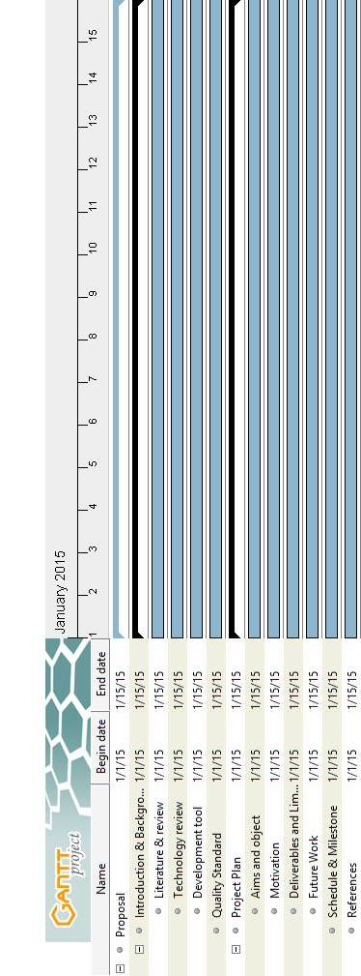

**Proposal Milestone**

*Figure 16 Proposal Period Milestone (Tentatively from early January to mid-January)*

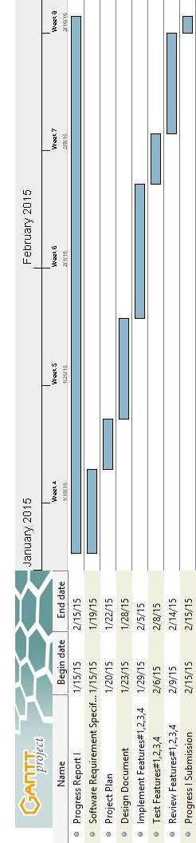

**Progress I**

*Figure 17 Progress I Period (Tentatively from mid-January to mid-February)*

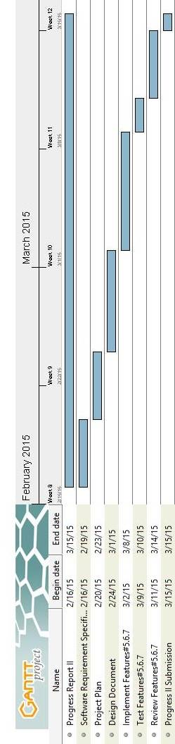

**Progress II**

*Figure 18 Progress II Period (Tentatively from mid-February to mid-March)*

# **Chapter Five | References**

[1] iSoftService

DATE 24/4/2015

<http://www.softnewer.com>

[2] ServiceCenter

DATE 24/4/2015

<http://www.programbunchee.com/scm.htm>

<http://www.thaiware.com>

[3] ASP.NET MVC

DATE 12/3/2015

[http://www.asp.net/mvc](http://www.asp.net/mvc%20)

[4] Cascading Style Sheets 3 (CSS3)

DATE 12/3/2015

<http://www.css3.info>

<http://www.w3schools.com/css/css3_intro.asp>

[5] HTML

DATE 12/3/2015

<http://www.w3schools.com/html>

[6] JavaScript

DATE 12/3/2015

<http://www.w3schools.com/js>

[7] Cloud Server

DATE 12/3/2015

<http://whatiscloud.com>

<http://www.rackspace.com/knowledge_center>

[8] Microsoft SQL Server

DATE 12/3/2015

[http://www.microsoft.com/sqlserver](http://www.microsoft.com/sqlserver%20)

[9] Microsoft Visual Studio

DATE 12/3/2015

<https://www.visualstudio.com>

<https://msdn.microsoft.com/en-us/vstudio>

[10] Adobe Photoshop

DATE 12/3/2015

<http://www.photoshop.com>

<http://www.adobe.com/products/photoshop.html>

[11] Mandrill

DATE 4/5/2015

<https://www.mandrill.com>

<https://mandrillapp.com>

[12] Window Azure

DATE 27/4/2015

<http://azure.microsoft.com>

[13] Internet Information Service (IIS)

DATE 24/4/2015

<http://www.iis.net>

[14] Bootstrap

DATE 4/5/2015

<http://getbootstrap.com>

<http://www.w3schools.com/bootstrap>

Figures

[1] *Figure 1 iSoftService's logo*

DATE 30/4/2015

<http://www.softnewer.com>

[2] *Figure 2 iSoftService main page Demo Version*

DATE 30/4/2015

<http://www.softnewer.com>

[3] *Figure 3 Service Center main page*

DATE 30/4/2015

<http://www.programbunchee.com/scm.htm>

http://www.vrtruelogic.com

[4] *Figure 4 Service Center repairing information page*

DATE 30/4/2015

<http://www.programbunchee.com/scm.htm>

<http://www.vrtruelogic.com>

[5] *Figure 5 ASP.NET MVC*

DATE 26/3/2015

<http://www.asp.net/mvc>

[6] *Figure 6 Cascading Style Sheets 3 (CSS3)*

DATE 26/3/2015

<http://www.css3.info>

[7] *Figure 7 HTML*

DATE 26/3/2015

<http://en.wikipedia.org/wiki/HTML>

[8] *Figure 8 JavaScript*

DATE 27/3/2015

<http://en.wikipedia.org/wiki/JavaScript>

[9] *Figure 9 Cloud server*

DATE 27/3/2015

<http://whatiscloud.com>

<http://www.rackspace.com/knowledge_center>

[10] *Figure 10 MS SQL Server*

DATE 28/3/2015

<http://www.microsoft.com/sqlserver>

[11] *Figure 11 MS Visual Studio*

DATE 28/3/2015

<https://www.visualstudio.com>

[12] *Figure 12 Photoshop*

DATE 28/3/2015

<http://www.photoshop.com>

[13] *Figure 13 Mandrill*

DATE 8/5/2015

<https://www.mandrill.com>

[14] *Figure 14 the architecture of Inventory and Asset Management system*

DATE 24/3/2015

[15] *Figure 15 Iterative development model*

DATE 24/3/2015

[16] *Figure 16 Proposal Period Milestone (Tentatively from early January to mid-January)*

DATE 21/5/2015

[17] *Figure 17 Progress I Period (Tentatively from mid-January to mid-February)*

DATE 21/5/2015

[18] *Figure 18 Progress II Period (Tentatively from mid-February to mid-March)*

DATE 21/5/2015